FOR IMMEDIATE RELEASE
MONDAY, JUNE 26, 2017

Contact: Jennifer Parks-Sturgeon
Rose+Moser+Allyn Public and Online Relations
Email: Jparks@RoseMoserAllynPR.com
Cell: 480.495.3806

**Sale Alert/Fall Unveiling**
Upgrade Your Summer Wardrobe with Great Bargains From My Sister’s Closet and Well Suited During Its
Summer Progressive Sale Aug. 12–25
Afterwards, Get Ready for Fall with My Sister’s Closet and Well Suited’s
Fall Unveiling. Doors Open Saturday, Aug. 26 at 8:00 a.m.
with Never Before Seen Items at MSC and WS!

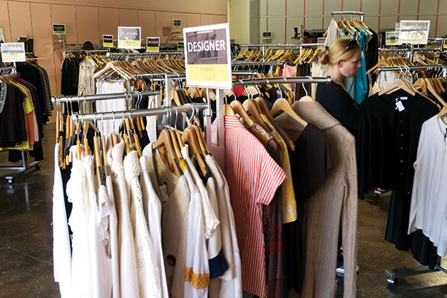
(PHOENIX) – Getting tired of wearing the same summer tops and shorts day after day? My Sister’s Closet and Well Suited are here to help! This is your chance to shop till you drop and have your summer go out with a bang. The Summer Progressive Sale at My Sister’s Closet and Well Suited starts Saturday, Aug. 12, 2017.

Here’s how it works: From August 12 – August 25, stop by any of the My Sister’s Closet and Well Suited locations and take advantage of 20-70% off everything in the store. The sale features all-time favorite designer clothing, handbags, shoes, hats, fine jewelry and accessories.

- Aug. 12 - Aug. 13 - 20% off everything in the store
- Aug. 14 - Aug. 16 - 30% off everything in the store
- Aug. 17 - Aug. 18 - 40% off everything in the store
- Aug. 19 - Aug. 22 - 50% off everything in the store
- Aug. 23 - Aug. 25 - 70% off everything in the store

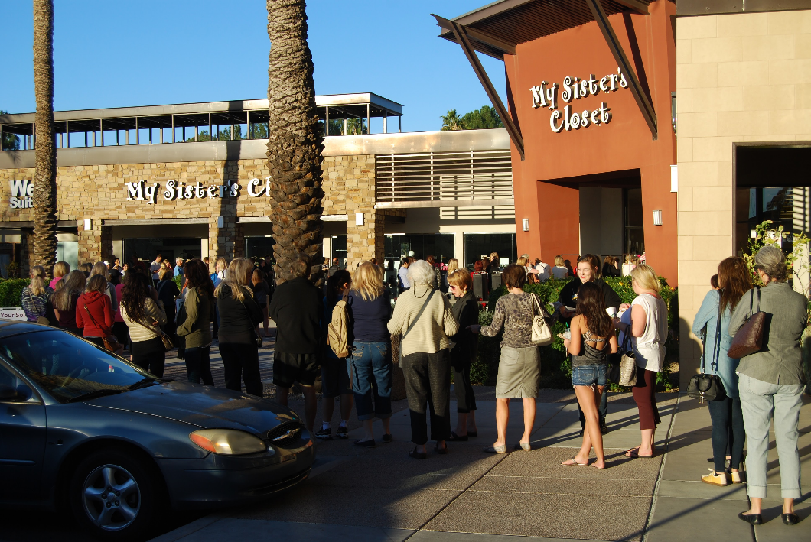
My Sister’s Closet and Well Suited will close at noon on Aug. 25th to clear out all summer items and to get ready for the big Fall Unveiling!

Just because you’ll be all set with stylish clothes for the rest of summer doesn’t mean you want to miss great bargains for the fall season as well. You will want to get in line early on Saturday, Aug. 26, for the annual Fall Unveiling with doors opening at 8:00 a.m.

More than 200 shoppers line up hours ahead of time outside Valley-wide locations of My Sister’s Closet and Well Suited hoping to get their hands on over 100,000 never-before-seen items, so you’ll want to get there early!

“Every year this sale is a huge hit, and this year we have some really exciting new looks in store for great prices,” said CEO and Founder, Ann Siner. “We have more than a 100,000 pieces of designer clothing, shoes, and accessories, and we’re offering them at prices you won’t find anywhere else in the Valley. If you’re into fashion, bargain shopping, or you just want to revamp your summer wardrobe, this sale is something you won’t want to miss. We’re also so excited to unveil our new fall collection at the end of August to our shoppers.”

Shop all of these looks and more at My Sister’s Closet and Well Suited. It’s the perfect place to find gifts for friends and loved ones with something for everyone at My Sister’s Closet, Well Suited and My Sister’s Attic. Don’t forget to pick up a few things for yourself too!

For media inquiries please contact Jennifer Parks at 480.495.3806 or by email at jparks@rosemoserallynpr.com.

Like My Sister’s Closet and Well Suited on Facebook and sign-up to get email updates on the hot ticket items on www.mysisterscloset.com.

My Sister’s Closet Locations (Well Suited located next door):
Desert Village at Pinnacle Peak
23269 N. Pima Rd. Scottsdale, AZ 85255
Phone: 480-419-6242
Mon-Fri: 9am-7pm
Sat: 9am-6pm
Sun: 10am-6pm
Lincoln Village in Scottsdale
6204 N. Scottsdale Rd. Scottsdale, AZ 85253
Phone: 480-443-4575
Mon-Fri: 9am-7pm
Sat: 9am-6pm
Sun: 10am-6pm
Town & Country in Phoenix
4869 N 20th St. Phoenix, AZ 85016
Phone: 602-954-6080
Mon-Fri: 9am-7pm
Sat: 9am-6pm
Sun: 10am-6pm
Las Tiendas in Chandler (Not a Well Suited Location)
2915 S. Alma School Rd. Chandler, AZ 85248
Phone: 480-722-1822
Mon-Fri: 9am-7pm
Sat: 9am-6pm
Sun: 10am-6pm

California Locations
My Sister’s Closet
8610 Genesee Ave., Ste. 200
San Diego, CA 92122
858-455-0045

My Sister’s Closet and Well Suited
146 N El Camino Real
Encinitas, CA 92024
760-436-3600

About My Sister’s Closet and Eco-Chic Consignment:
Eco-Chic Consignments, Inc. is a family of three high-end designer consignment concepts—My Sister’s Closet (women), My Sister’s Attic (home furnishings) and Well Suited (men). Each store sells consigned items at 60 – 90% below retail value. Founded more than 26 years ago, Eco-Chic Consignments, Inc. has since grown into a $25+ million business with 15 locations in some of the nicest neighborhoods of Arizona and California. The company ranked no. 2,896 on the Inc. 5000 list. To learn more about Eco-Chic Consignments, Inc. and its resale brands, visit mysisterscloset.com.

